***Section* 3.6 – Alternating Series, Absolute and Conditional Convergence**

A series in which the terms are alternately positive and negative is an alternating series.





***Theorem* − The Alternating Series Test (Leibniz’s Test)**

The series 

Converges if all three of the following conditions are satisfied:

1. The  are all positive.
2. The positive  are (eventually) non-increasing:  for all , for some integer N.
3. 

***Example***

The alternating harmonic series 

***Solution***

1. 
2. 
3. 

Therefore, the series converges.

***Theorem* − The Alternating Series Estimation Theorem**

IF the alternating series  satisfies the three conditions, then for 



Approximates the sum *L* of the series with an error whose absolute values is less than , the absolute value of the first unused term. Furthermore, the sum L lies between any two successive partial sums  and  and the remainder, , has the same sign as the first unused term.

**Absolute and Conditional Convergence**

***Definition***

A series  ***converges absolutely*** (is ***absolutely convergent***) if the corresponding series of absolute values, , converges.

***Definition***

A series converges but does not converge absolutely ***converges conditionally***.

***Theorem***

If  converges, then  converges.

***Example***

For  the corresponding series of absolute values is the convergent series



The original series converges because it converges absolutely.

***Example***

For  , which contains both positive and negative terms, the corresponding series of absolute values is



Which converges by comparison with  because  for every *n*.

The original series converges absolutely; therefore, it converges.

**Rearranging Series**

***Theorem***

If  converges absolutely, and  is any arrangement of the sequence , then  converges absolutely and 

***Exercises Section* 3.6 – Alternating Series, Absolute and Conditional Convergence**

Determine if the alternating series converges or diverges

|  |  |  |
| --- | --- | --- |
|  |  |  |

Determine if the series converge absolutely or conditionally, or diverges

|  |  |  |
| --- | --- | --- |
|  |  |  |

|  |  |  |
| --- | --- | --- |
|  |  |  |

For what values of *x* does the series converge absolutely? Converge conditionally? Diverge?

|  |  |  |
| --- | --- | --- |
|  |  |  |

Use any method to determine if the series converges or diverges.

|  |  |  |
| --- | --- | --- |
|  |  |  |

|  |  |  |
| --- | --- | --- |
|  |  |  |

1. Use a Riemann sum argument to show that 

Then for what values of *x* does the series  converge absolutely? Converge conditionally? Diverge? (*Use the ratio test first*)

1. Let  be the *n*th partial sum of . Find the  and 
2. It can be proved that if a series converges absolutely, then its terms may be summed in any order without changing the value of the series. However, if a series converges conditionally, then the value of the series depends on the order of summation. For example, the (conditionally convergent) alternating harmonic series has the value



Show that by rearranging the terms (so the sign pattern is ++−),



1. A crew of workers is constructing a tunnel through a mountain. Understandably, the rate of construction decreases because rocks and earth must be removed a greater distance as the tunnel gets longer. Suppose that each week the crew digs 0.95 of the distance it dug the previous week. In the first week, the crew constructed 100 *m* of tunnel.
2. How far does the crew dig in 10 *weeks*? 20 *weeks*? *N* weeks?
3. What is the longest tunnel the crew can build at this rate?
4. The time required to dig 100 *m* increases by 10% each *week*, starting with 1 *week* to dig the first 100 *m*. Can the crew complete a 1.5 *km* tunnel in 10 *weeks*? Explain.
5. Consider the alternating series



1. Write out the first ten terms of the series, group them in pairs, and show that the even partial sums of the series form the (divergent) harmonic series.
2. Show that 
3. Explain why the series diverges even though the terms of the series approach zero.
4. The concentration in the blood resulting from a single dose of a drug normally decreases with time as the drug is eliminated from the body. Doses may therefore need to be repeated periodically to keep the concentration from dropping below some particular level. One model for the effect of repeated doses gives the residual concentration just before the  does as



Where the change in concentration achievable by a single dose ,

 the elimination constant , and

 time between doses (*h*).

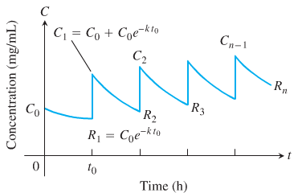

1. Write  in closed form as a single fraction, and find 
2. Calculate  and  for   and . How good as estimate of *R* is 
3. If  and , find the smallest *n* such that 
4. If a drug is known to be ineffective below a concentration  and harmful above some higher concentration , one needs to find values of  and  that will produce a concentration that is safe (not above ) but effective (not below ).

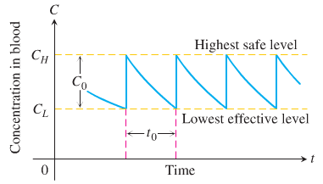

We want to find values for  and for which



Thus, . The resulting equation simplifies to



To reach an effective level rapidly, one might administer a “loading” dose that would produce a concentration of . This could be followed every hours by a dose that raises the concentration by .

1. Verify the preceding equation for .
2. If  and the highest safe concentration is *e* times the lowest effective concentration, find the length of time between doses that will assure safe and effective concentrations.
3. Given  determine a scheme for administering the drug.
4. Suppose that  and the smallest effective concentration is 0.03 *mg/mL*. A single dose that produces a concentration of 0.1 *mg/mL* is administered. About how long will the drug remain effective?